**Csv stored file format**

**Home Page:**

**Insert data in CSV File >>**

**Read customer data from CSV file**

**// find all customers sorted by id**

**Sort customers by ID (Ascending)**

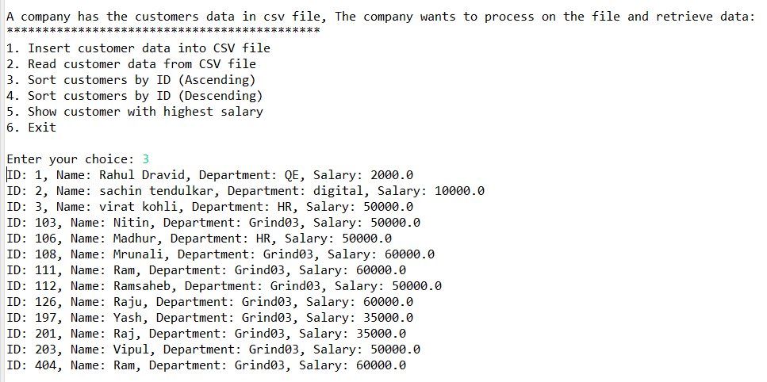

**Sort customers by ID (Descending)**

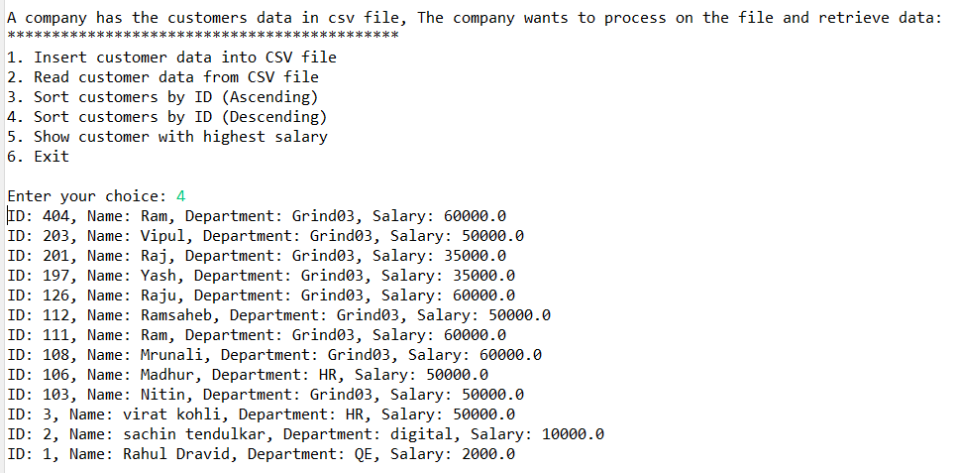

**//find customer with highest balance**

**// transformed file in the format mentioned above**

